Standard Operating Procedure
Benzene

Section 1 – Lab-Specific Information
Building/Room(s) covered by this SOP: BAG 191/333
Unit or department: Chemistry
Principal Investigator Name: Eric Camp
Principal Investigator Signature/Date: 4/2/2026

Important Definitions
- Flammable Liquid: Liquids having a flash point below 38ºC (100ºF).
- Combustible Liquid: Liquids having a flash point at or above 38ºC (100ºF) and no greater than 93ºC (200ºF).
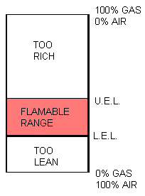
- Flash Point: The minimum temperature at which vapors are formed on the surface of a substance in sufficient quantity to ignite when exposed to an ignition source.
- Fire Point: The minimum temperature at which self-sustained combustion of a substance will occur upon or after exposure to an ignition source.
- Boiling Point: The temperature at which the vapor pressure of a liquid equals the atmospheric pressure and the liquid changes into a vapor.
- Auto Ignition Temperature: The minimum temperature at which self-sustained combustion will occur in the absence of an ignition source.
- Lower Explosive Limit (LEL): The lowest concentration (percentage) of a gas or a vapor in air capable of producing a flash of fire in presence of an ignition source (arc, flame, heat).
- Upper Explosive Limit (UEL): Highest concentration (percentage) of a gas or a vapor in air capable of producing a flash of fire in presence of an ignition source (arc, flame, heat).
- Action level: a concentration designated in regulations for a specific substance, calculated as an eight (8)-hour time-weighted average, which initiates certain required activities such as exposure monitoring and medical surveillance.
- Permissible exposure limit (PEL): the exposure limit designated in regulations for a specific substance, calculated as an eight (8)-hour time-weighted average, that should not be exceeded in a work day.
- Short-term exposure limit (STEL): the airborne concentration designate in regulations for a specific substance that should not be exceeded in a 15 minute period.

Section 2 – Hazards
Benzene liquid is highly flammable. Keep flammable or combustible liquid away from heat, sparks, open flames, and hot surfaces. Flammable and combustible liquids often have other hazards associated with them such as toxicity and the ability to form explosive organic peroxides. Make sure that all of the potential hazards are understood before handling.
Benzene can affect your health if inhaled, if it contacts skin or eyes, or if ingested. The most frequent work place route of entry is by inhalation, but benzene can be absorbed through the intact skin and will be absorbed faster through abraded skin.
High, short-term (acute) exposures may result in feelings of breathlessness, irritability, euphoria, giddiness, or irritation of the eyes, nose or respiratory tract. Also, headache, dizziness and feelings of nausea or intoxication may occur. Severe exposures may lead to convulsions and loss of consciousness.
Periodic exposures at lower levels (chronic exposures) may result in various blood disorders, ranging from anemia to leukemia (an irreversible, fatal disease). Many blood disorders associated with benzene exposure may occur without symptoms.
Exposure Limits:
WAC PEL (8 HR. TWA): 1.0 ppm
WAC STEL (15 min TWA): 5.0 ppm
WAC Action Level (8 HR. TWA): 0.5 ppm
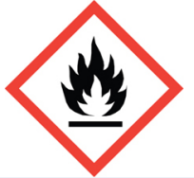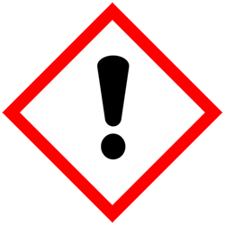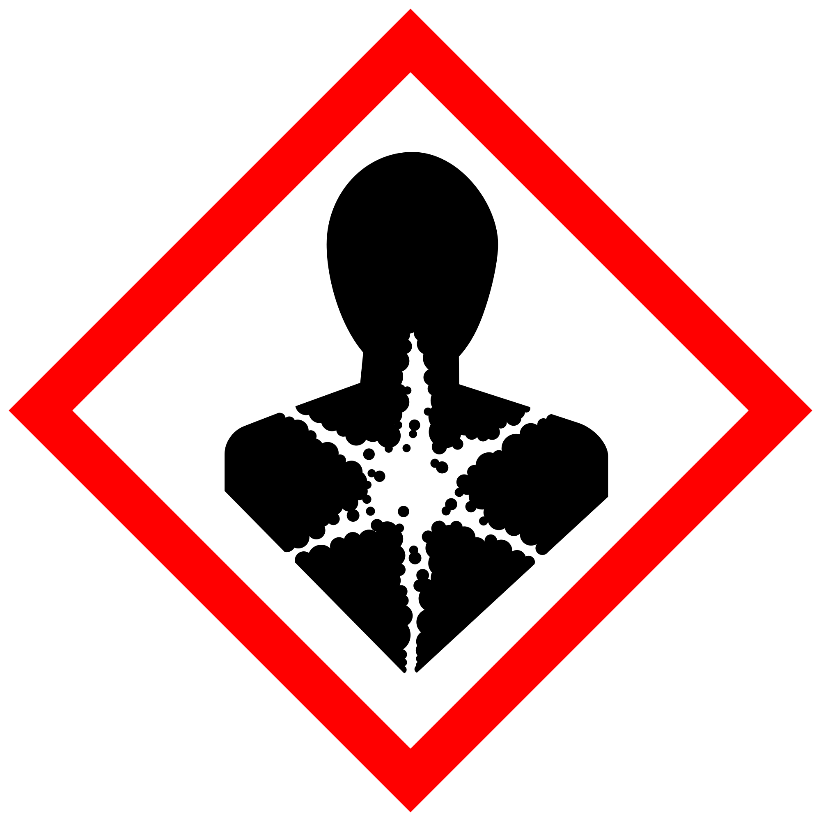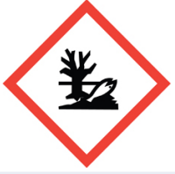

Section 3 – Engineering Controls and Personal Protective Equipment (PPE)

Engineering controls
Conduct work in a chemical fume hood

Hygiene measures
Avoid contact with skin, eyes, and clothing. Wash hands after removing PPE, before breaks, and immediately after handling the chemical. If benzene come(s) into contact with any PPE, the PPE shall be immediately removed and discarded properly. Any potentially exposed body parts should be washed immediately.

Skin and body protection
Chemically compatible laboratory coats that fully extend to the wrist must be worn and be appropriately sized for the individual and buttoned to their full length. Personnel must also wear full-length pants, or equivalent, and close-toe shoes. The area of skin between the shoe and ankle must not be exposed.

Hand protection
Hand protection is required for the activities described in this SOP. Nitrile gloves are suitable for low volume applications. Wearing two pairs of nitrile gloves is recommended. If handling a high volume (> 1 liters) of flammable or combustible liquid, then disposable gloves are not suitable; a more heavy duty glove such as a butyl rubber is required.
Gloves must be inspected prior to use, including a check for pinholes.
Use proper glove removal technique (without touching glove’s outer surface) to avoid skin contact with this product. Dispose of contaminated gloves after use in accordance with applicable laws and good laboratory practices. Wash and dry hands immediately after glove removal.

Eye protection
ANSI Z87.1-compliant splash goggles are required for all work with benzene. Ordinary prescription glasses will NOT provide adequate protection unless they also meet the Z87.1 standard and have compliant side shields.

Respiratory protection
Respiratory protection is not required for the activities described in this SOP.

Section 4 – Special handling and storage requirements
Benzene should be kept in fire approved fridge or vented flammables cabinet. Move bottle to fume hood before opening.

Section 5 – Spill and accident procedures
Small spills (<10mL) in hoods will quickly evaporate. Larger spills (<1L), use an absorbant pad from the spill kit, put in a ziplock bag, label with a hazardous waste sticker (95% non-regulated absorbent material, 5% benzene) and submit to EHS
Larger spills, evacuate and contact a supervisor.
Do not attempt to clean up any spill if not trained or comfortable. Evacuate the area and call 9-1-1 on campus phone for help. If the spill is out of control, call 9-1-1. If a person is injured, exposed or suspected of being exposed, call 9-1-1 and follow the EXPOSURE PROCEDURES (below).
For questions on spill cleanup, contact EH&S spill consultants at 206‐543‐0467 during normal business hours (Monday-Friday, 8 a.m. to 5 p.m.).
Any spill, exposure or near miss incident requires the involved person or supervisor to complete and submit the Online Accident Reporting System (OARS) form on the EH&S website within 24 hours (certain types of incidents require immediate notification) at oars.ehs.washington.edu.
Exposures: If a person is injured, exposed, or suspected of being exposed to Benzene, follow procedures listed here:
Perform first aid immediately.
- Inhalation exposure: Move out of contaminated area; get medical help.
- Sharps injury (needle stick or subcutaneous exposure): Scrub exposed area thoroughly for 15 minutes using warm water and sudsing soap.
- Skin exposure: Use the nearest safety shower or sink for 15 minutes; stay under the and remove clothing if nessisary; use a clean lab coat or spare clothing for cover‐up.
- Eye exposure: Use the eye wash for 15 minutes while holding eyelids open.
Get Help.
- Call 9-1-1 or go to nearest Emergency Department (ED); provide details of exposure:
    - Agent
    - Dose
    - Route of exposure
    - Time since exposure
- Bring the SDS and this SOP to the Emergency Department
- Notify your supervisor as soon as possible for assistance
- Secure the area before leaving; lock doors and indicate spill if needed
Report the incident to Environmental Health & Safety.
- Notify EH&S immediately after providing first aid and/or getting help.
  - During business hours (M‐F/8‐5), call 206‐543‐7262.
  - Outside of business hours, call 206‐685‐UWPD (8973) to be routed to EH&S Staff On Call.
- The involved person or supervisor submits the UW Online Accident Reporting System (OARS) form on the EH&S website within 24 hours (certain types of incidents require immediate notification) at oars.ehs.washington.edu.

Section 6 – Waste accumulation and disposal procedures
Put in appropriate container, add waste sticker and submit to EH&S

Section 7 – Protocol
See Lab manual
NOTE: Any deviation from this SOP requires approval from Principal Investigator.

Section 8 – Special Precautions for animal use ( Yes No)
PARTICULARLY HAZARDOUS SUBSTANCE INVOLVED?
YES: Sections #9 to #11 are Mandatory.

Section 9 – Approvals required
All staff working with benzene must be trained on this SOP prior to starting work. They must also review the benzene SDS, and it must be readily available in the laboratory. All training must be documented and maintained by the PI or their designee.
Staff should review SOP and discuss with TAs during trainings

Section 10 – Decontamination
Wash with acetone, let dry in a fume hood

Section 11 – Designated area

Use in fume hood only

