Standard Operating Procedure
Handling Cryogenic Liquids

Lab-Specific Information
Chemical(s) covered by this SOP: | Liquid Nitrogen/Liquid Helium
Building/Room(s) covered by this SOP: | Bagley, Chemistry Building
Department: | Chemistry
Principal Investigator Name: | Click here to enter a date.
Principal Investigator Approval Signature: | Click here to enter text.

University of Washington
#1 Process | - Containers for cryogenic liquids must not be closed completely. Although liquid nitrogen and helium are stored in vacuum-jacketed vessels (dewars), there is always some heat leak into the dewar such that there is boil-off of the liquid at all times. Pressure will build up and if no exit is available to the gas, the container would ultimately explode. A pressure relief valve is attached to the dewar to keep the internal pressure very low. Make sure you are aware of the presence of a protective pressure relief valve on any dewar that you handle.  - If a crack in the metal between the liquid and the vacuum space of a dewar were to occur, a rapid pressure build-up in this relatively confined space will occur since it would no longer be insulated by vacuum. For this reason, all metal dewars must be constructed such that a pressure relief valve or rupture disk connected to the vacuum space will relieve excess pressure prior to sufficient build-up to cause explosion. For the same reason, all glass dewars must be wrapped with tape or netting to prevent flying glass in the event of an explosion.  - Do not leave openings to cold dewars wide open to the atmosphere for any longer than is absolutely necessary for the manipulations required for transferring liquids. The temperature of liquid nitrogen at atmospheric pressure is -196°C and of liquid helium is -269°C. Air (and its contents) will condense into the dewar and can cause blockages that are potentially dangerous and that will almost certainly interfere with some aspect of the liquid transfer or with the operation of the instrument in the long run. The freezing point of liquid oxygen is -183°C, i.e., above that of these cryogenic fluids. The collection of liquid oxygen into these colder liquids is an explosion hazard!  - The very cold temperatures of cryogenic fluids necessitate complete avoidance of contact with the skin. Frostbite, i.e. “burns” from extreme cold, will occur very quickly upon contact, especially if clothing, shoes, etc., hold the liquid tightly to the skin. Take care about spills and use appropriate hand protection while transferring these liquids. Use thermally insulated gloves; thin gloves will not help. Take care to avoid contact with the portions of the transfer line that have been inserted into the dewars during the transfer as they will be cold enough to cause cold “burns” for quite a while after removal from the dewars.  - Liquid helium transfer lines are vacuum jacketed and should not be very cold to touch during the initial cool down of the transfer line. If a transfer line appears to be too cold, it is time to re-pump the vacuum space. The heat of vaporization of liquid helium is very small, i.e., ~10% of that of liquid nitrogen. Thus, helium is never seen as a liquid during transfer operations. A “plume” or “flame” is the indicator that liquid helium is coming through the transfer line during the cool down and is ready to be inserted.
#2 Chemicals and Hazards | 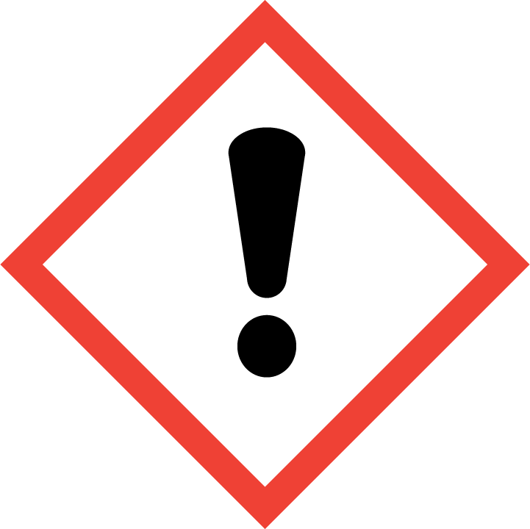  - Nitrogen and Helium are not toxic, but are simple asphyxiates.  - Cryogenic fluids are materials with extremely low boiling points (i.e., less than – 150 °F). At these temperatures, tissue burns may be sustained after contact with the fluids, surfaces cooled by the fluids, or by evolving gases. The hazard is comparable to that of handling boiling water.  - One special property of cryogenic liquids is that they undergo substantial volume expansion when converted to a gas phase, which can potentially lead to an oxygen deficient atmosphere where ventilation is limited.
#3 Personal Protective Equipment (PPE) | - Safety glasses/goggles  - Gloves: Handle with thermally insulated gloves. Gloves must be inspected prior to use.  - Lab coat/apron/coveralls: Long pants, lab coat, and closed toed shoes should be worn when working with cryogenic fluids. Never allow any unprotected part of the body to touch non insulated pipes or vessels which contain cryogenic fluids. The extremely cold metal will cause the flesh to stick fast and tear when one attempts to withdraw from it. Frostbite is likely to occur.
#4 Environmental/  Ventilation Controls | Use cryogenic fluids only in well-ventilated areas. Unconsciousness occurs without warning in an oxygen deficient atmosphere. Neither nitrogen nor helium gas is toxic, but if too much oxygen is displaced by these gases, the danger of asphyxiation is very real! These gases expand their volumes by a factor of ~700 when they are evaporated and allowed to warm up to room temperature. A fume hood or local exhaust ventilation system (e.g., snorkel exhaust hood, benchtop fume extractor) designed to
#5 Special Handling Procedures & Storage Requirements | Store and transport cryogenic fluids only in Dewars or cryogenic liquid cylinders designed for that particular cryogen. Cryogenic liquid dewars are to be stored in well-ventilated areas with the pressure relief valve in the opened position.
#6 Spill and Accident Procedures | Assess the extent of danger. In the event of a large spill, you should alert others immediately in the vicinity to evacuate, close the doors of the lab if opened, and restrict access to the work area.
#7 Waste Disposal | No waste disposal necessary, pour unused fluids back into main dewar in a well ventilated area or in back of a hood to evaporate.

