Standard Operating Procedure for Mercury
REQUIRED: List chemical(s) and CAS numbers here

Section 1 – Lab-Specific Information
Building/Room(s) covered by this SOP: Bagley, Chemistry Building
Unit or department: Chemistry
Principal Investigator Name:
Principal Investigator Signature/Date:
This SOP was created by (if not PI):
Name/Title/Date/Signature

Section 2 – Hazards
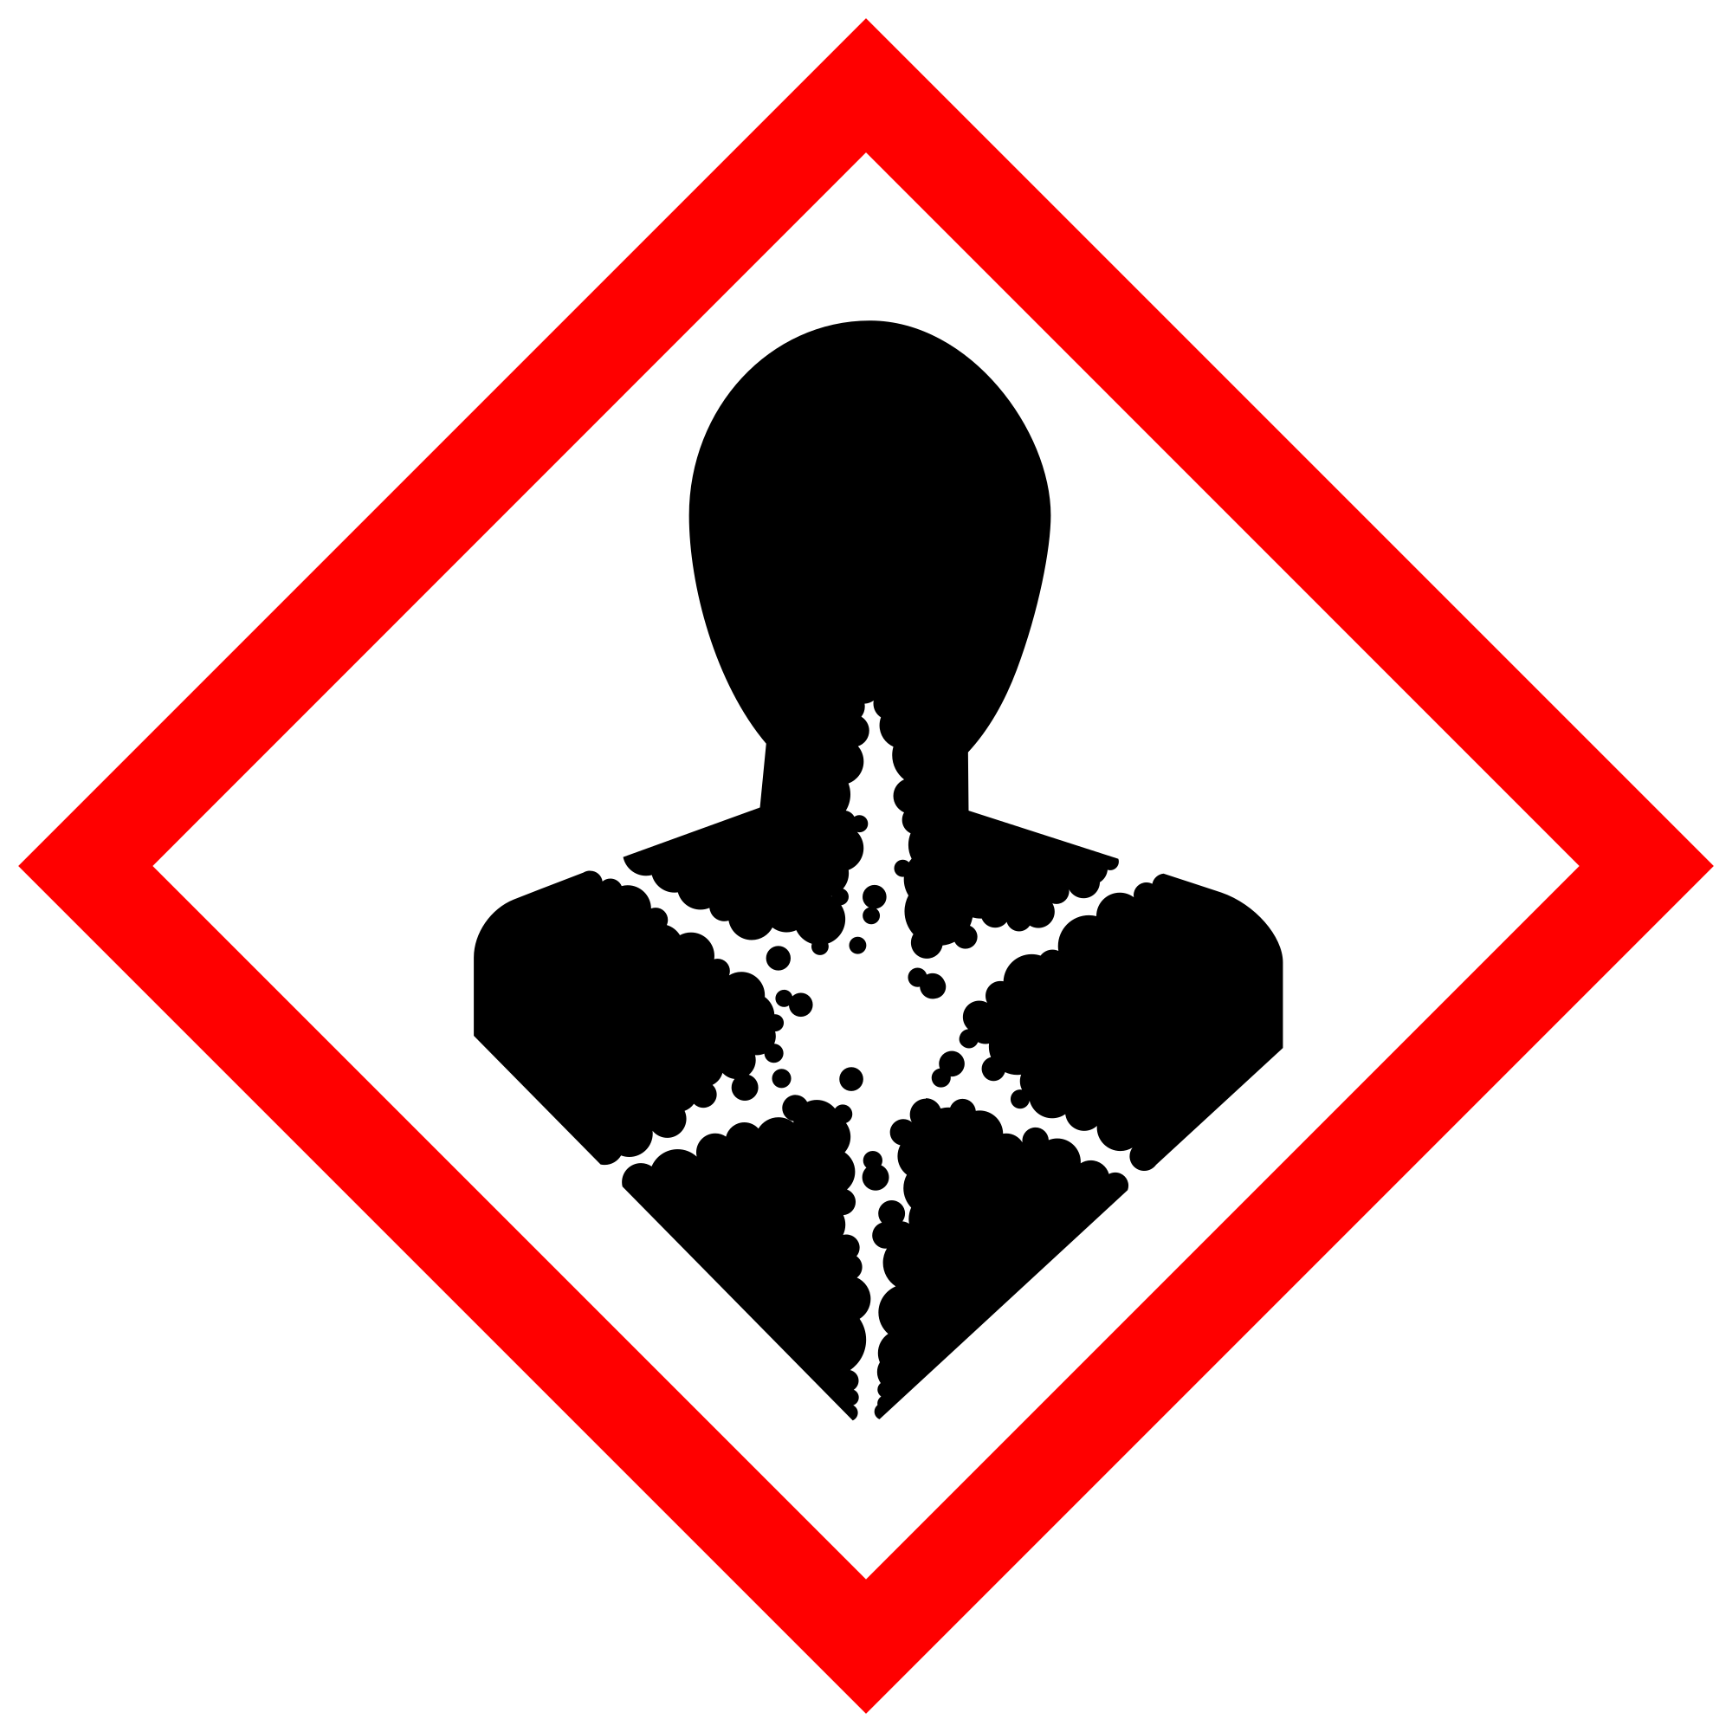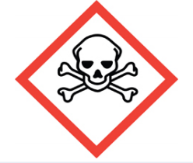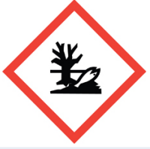

Section 3 – Engineering Controls and Personal Protective Equipment (PPE)

Engineering controls

Use of Mercury must be conducted in a properly functioning chemical fume hood.
Labs with Mercury must have a mercury spill kit on hand

Hygiene measures
Avoid contact with skin, eyes, and clothing. Wash hands after removing PPE, before breaks, and immediately after handling the chemical. If Mercury come(s) into contact with any PPE, the PPE shall be immediately removed and discarded properly. Any potentially exposed body parts should be washed immediately.

Skin and body protection
Chemically compatible laboratory coats that fully extend to the wrist must be worn and be appropriately sized for the individual and buttoned to their full length. Personnel must also wear full-length pants, or equivalent, and close-toe shoes. The area of skin between the shoe and ankle must not be exposed.

Hand protection
Hand protection is required for the activities described in this SOP.

Gloves must be worn. Use proper glove removal technique to avoid any skin contact. Nitrile or neoprene gloves are recommended. Wearing two pair of gloves is recommended. Check the resources below for a more suitable glove. NOTE: Consult with your preferred glove manufacturer to ensure that the gloves you plan on using are compatible with Mercury.

Eye protection
ANSI Z87.1-compliant eye protection is required for all work with mercury. Ordinary prescription glasses will NOT provide adequate protection unless they also meet the Z87.1 standard and have compliant side shields.

Respiratory protection
Respiratory protection is only required for the activities described in this SOP when handling a spill outside of a fume hood..

Contact your supervisor or safety lead for assistance in using a respiratory device and/or contact EH&S for guidance on using one.

Section 4 – Special handling and storage requirements

•A designated storage area must be established for Mercury and the area should be posted with a “Caution, Carcinogen, Reproductive Toxins, or Extremely Toxic Chemicals” label provided by REM (as shown to the right).

•Avoid contact with skin and eyes and inhalation.

•Keep containers tightly closed.

•Store in a cool, dry and well-ventilated area away from incompatible substances such as strong oxidizing agents, ammonia, azide compounds, nitrate compounds, chlorate compounds, and copper compounds.

•Containers which are opened must be carefully resealed and kept upright to prevent leakage.

•A suitable storage location is a flammable storage cabinet or lab cabinet that does not contain incompatibles.

Section 5 – Spill and accident procedures
For small spills, use a mercury spill kit and follow directions on the package.
Typical instructions include:
- Evacuate all other researchers that are not actively assisting
- Put on PPE with mask, two sets of nitrile/butyl gloves
- Use scoop to collect mercury globules into one large globules
- Use syringe (no needle) or pipette bulb to transfer mercury into an appropriate and sturdy container.
- Dust area with a mercury absorbing powder, often zinc or sulfur (never mix zinc and sulfur, violent exothermic reaction). Follow any instructions regarding the absorbing powder.
- Collect powder and place into mercury waste container.
- Put all contaminated materials such as gloves, syringe, paper towels, and put them into a Ziplock bag.
- Put waste stickers on and submit to EH&S
For questions on spill cleanup, contact EH&S spill consultants at 206‐543‐0467 during normal business hours (Monday-Friday, 8 a.m. to 5 p.m.).
Any spill, exposure or near miss incident requires the involved person or supervisor to complete and submit the UW Online Accident Reporting System (OARS) form on the EH&S website within 24 hours (certain types of incidents require immediate notification).
Exposures: If a person is injured, exposed, or suspected of being exposed to Mercury, follow procedures listed here:
Perform first aid immediately.
- Inhalation exposure: Move out of contaminated area; get medical help.
- Sharps injury (needle stick or subcutaneous exposure): Scrub exposed area thoroughly for 15 minutes using warm water and sudsing soap.
- Skin exposure: Use the nearest safety shower for 15 minutes; stay under the shower and remove clothing; use a clean lab coat or spare clothing for cover‐up.
- Eye exposure: Use the eye wash for 15 minutes while holding eyelids open.
Get Help.
- Call 9-1-1 or go to nearest Emergency Department (ED); provide details of exposure:
    - Agent
    - Dose
    - Route of exposure
    - Time since exposure
- Bring the SDS and this SOP to the Emergency Department
- Notify your supervisor as soon as possible for assistance
- Secure the area before leaving; lock doors and indicate spill if needed
Report the incident to Environmental Health & Safety.
- Notify EH&S immediately after providing first aid and/or getting help.
  - During business hours (M‐F/8‐5), call 206‐543‐7262.
  - Outside of business hours, call 206‐685‐UWPD (8973) to be routed to EH&S Staff On Call.
- Any spill, exposure or near miss incident requires the involved person or supervisor to complete and submit the UW Online Accident Reporting System (OARS) form on the EH&S website within 24 hours (certain types of incidents require immediate notification).
Refer to SDS for additional chemical-specific guidance; include pertinent information here.

Section 6 – Waste accumulation and disposal procedures
Submit waste in a timely manner using well sealed waste bottles and appropriately labeled. Please waste any mercury thermometers and replace with alcohol or non-mercury equivalent.
Store in secondary containment in fume hoods, away from incompatible materials.
All chemical waste containers must be labeled with a UW Hazardous Waste Label. Refer to How to Label Chemical Waste Containers.
To request a collection of chemical waste, submit a form on the Chemical Waste Disposal webpage on the EH&S website or directly in MyChem inventory. Contact EH&S at 206.616.5835 or chmwaste@uw.edu with questions.
Work area decontamination procedures as appropriate for the chemical in use should be followed.

Section 7 – Protocol (Add lab specific Protocol/Procedure here)
REQUIRED - Insert or attach detailed laboratory-specific procedures for the process, hazardous chemical(s), or hazard class. You may also include any relevant supporting resources such as journal citations, etc. that are applicable
Refer to Section 2 of the UW Laboratory Safety Manual on the EH&S website for additional guidance on chemical management and preparation for use for particularly hazardous substances (PHSs).
NOTE: Any deviation from this SOP requires approval from Principal Investigator.

Section 8 – Special Precautions for animal use (☐Yes ☐ No)
N/A
PARTICULARLY HAZARDOUS SUBSTANCE INVOLVED?
☒YES: Sections #9 to #11 are Mandatory.
☐NO: Sections #9 to #11 are Optional.
EH&S flags Particularly Hazardous Chemicals in MyChem based on hazards.

Section 9 – Approvals required
All staff working with mercury must be trained on this SOP prior to starting work. They must also review the mercury SDS, and it must be readily available in the laboratory. All training must be documented and maintained by the PI or their designee.
Describe any requirements for obtaining authorization before use of the chemical for the procedure, operation, or activity can be performed.

Examples:
- A worker must have [specific training] documented before performing described procedure for the first time.
- A medical examination must be completed prior to respirator use (for lead, dust, pathological organisms).
- Other authorizations required before a person can independently perform a process using a particularly hazardous substance.

Section 10 – Decontamination

Decontamination is equivalent to the small spill procedure
- Put on PPE with mask, two sets of nitrile/butyl gloves
- Use scoop to collect mercury globules into one large globules
- Use syringe (no needle) or pipette bulb to transfer mercury into an appropriate and sturdy container.
- Dust area with a mercury absorbing powder, often zinc or sulfur (never mix zinc and sulfur, violent exothermic reaction). Follow any instructions regarding the absorbing powder.
- Collect powder and place into mercury waste container.
- Put all contaminated materials such as gloves, syringe, paper towels, and put them into a Ziplock bag.
- Put waste stickers on and submit to EH&S

Section 11 – Designated area

REQUIRED - Identify specific areas where the particularly hazardous chemicals may be used (e.g., glove boxes, restricted access hoods, perchloric/hot acid fume hoods, or designated portions of the laboratory).

Section 12 – Documentation of training (signature of all users is required)
- Prior to using substances included in this SOP, laboratory personnel must be trained on the hazards described in this SOP, how to protect themselves from the hazards, and emergency procedures.
- Ready access to this SOP and to a Safety Data Sheet for each hazardous material described in the SOP must be made available in the lab space(s) where these substances are used.
- The Principal Investigator (PI), or Responsible Party, if the activity does not involve a PI, must ensure that their laboratory personnel have attended appropriate laboratory safety training (and refresher training where applicable).
- Training must be repeated following any revision to the content of this SOP.
- Training must be documented. This training sheet is provided as one option; other forms of training documentation (including electronic) are acceptable but records must be accessible and immediately available upon request.

I have read and understand the content of this SOP:
Name | Signature | Date

