Standard Operating Procedure for Nitric Acid

Section 1 – Lab-Specific Information
Building/Room(s) covered by this SOP: All UG Lab Spaces
Unit or department: Chemistry
Principal Investigator Name: Eric Camp
Principal Investigator Signature/Date: 4/1/2026

Section 2 – Hazards
Highly corrosive, Oxidizer
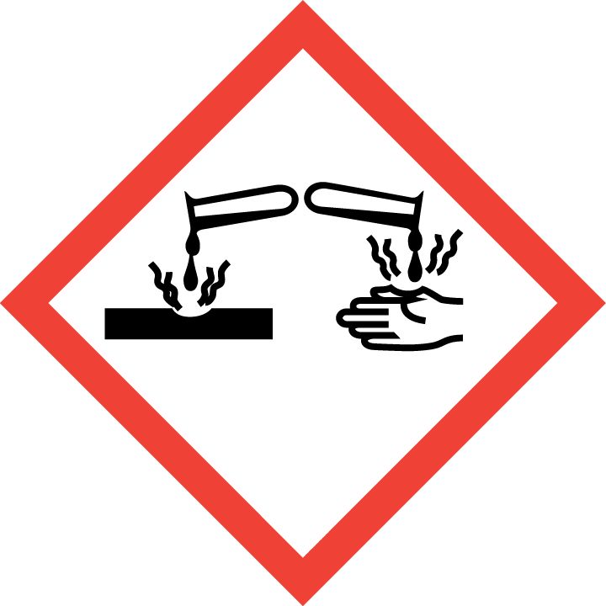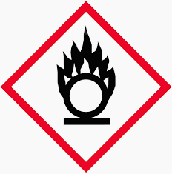

Section 3 – Engineering Controls and Personal Protective Equipment (PPE)

Engineering controls
Use Concentrated acids in a hood. Diluted acids are okay out of hood.

Hygiene measures
Avoid contact with skin, eyes, and clothing. Wash hands after removing PPE, before breaks, and immediately after handling the chemical. If acids come(s) into contact with any PPE, the PPE shall be immediately removed and discarded properly. Any potentially exposed body parts should be washed immediately.

Skin and body protection
Chemically compatible laboratory coats that fully extend to the wrist must be worn and be appropriately sized for the individual and buttoned to their full length. Personnel must also wear full-length pants, or equivalent, and close-toe shoes. The area of skin between the shoe and ankle must not be exposed.

Hand protection
Nitrile or butyl gloves are required for the activities described in this SOP.
Gloves must be inspected prior to use, including a check for pinholes.
Use proper glove removal technique (without touching glove’s outer surface) to avoid skin contact with this product. Dispose of contaminated gloves after use in accordance with applicable laws and good laboratory practices. Wash and dry hands immediately after glove removal.

Eye protection
ANSI Z87.1-compliant splash goggles are required for all work with acids. Ordinary prescription glasses will NOT provide adequate protection unless they also meet the Z87.1 standard and have compliant side shields.

Respiratory protection
Respiratory protection not required for the activities described in this SOP.

Section 4 – Special handling and storage requirements
Store in secondary containment away from other acids, bases, and organics. Transport using LDPE bottle carriers

Section 5 – Spill and accident procedures
Concentrated Acids:
- Small spills (<50mL) neutralize with sodium bicarbonate. Wipe and wash down drain with excess of water. If there is a large quantity of bicarbonate, double bag it in a Ziplock bag, write “Sodium Bicarbonate, Non-Hazardous, Non-Regulated” and put in the trash.
- Large Spills (>50mL). If the spill is outside of a fume hood, evacuate the area and contact your supervisor for assistance.
Dilute Acids:
- Small spills (<50mL) neutralize with sodium bicarbonate. Wipe and wash down drain with excess of water. If there is a large quantity of bicarbonate, double bag it in a Ziplock bag, write “Sodium Bicarbonate, Non-Hazardous, Non-Regulated” and put in the trash.
- Large Spills (>50mL) neutralize with sodium bicarbonate. Absorb with large absorbent pads. If there is a large quantity of bicarbonate, double bag it in a Ziplock bag, write “Sodium Bicarbonate, Non-Hazardous, Non-Regulated” and put in the trash. If the spill is very large and/or you need assistance, call staff/supervisor for assistance.
Chemical spills must be cleaned up as soon as possible by properly protected and trained personnel. All other persons should leave the area.
Do not attempt to clean up any spill if not trained or comfortable. Evacuate the area and call 9-1-1 on campus phone for help. If the spill is out of control, call 9-1-1. If a person is injured, exposed or suspected of being exposed, call 9-1-1 and follow the EXPOSURE PROCEDURES (below).
For questions on spill cleanup, contact EH&S spill consultants at 206‐543‐0467 during normal business hours (Monday-Friday, 8 a.m. to 5 p.m.).
Any spill, exposure or near miss incident requires the involved person or supervisor to complete and submit the UW Online Accident Reporting System (OARS) form on the EH&S website within 24 hours (certain types of incidents require immediate notification).
Exposures: If a person is injured, exposed, or suspected of being exposed to acids, follow procedures listed here:
Perform first aid immediately.
- Inhalation exposure: Move out of contaminated area; get medical help if there is difficulty breathing.
- Skin exposure: Use the nearest safety shower or sink for 15 minutes; stay under the shower and remove clothing; use a clean lab coat or spare clothing for cover‐up.
- Eye exposure: Use the eye wash for 15 minutes while holding eyelids open.
Get Help.
- Call 9-1-1 or go to nearest Emergency Department (ED); provide details of exposure:
    - Agent
    - Dose
    - Route of exposure
    - Time since exposure
- Bring the SDS and this SOP to the Emergency Department
- Notify your supervisor as soon as possible for assistance
- Secure the area before leaving; lock doors and indicate spill if needed
Report the incident to Environmental Health & Safety.
- Notify EH&S immediately after providing first aid and/or getting help.
  - During business hours (M‐F/8‐5), call 206‐543‐7262.
  - Outside of business hours, call 206‐685‐UWPD (8973) to be routed to EH&S Staff On Call.
- Any spill, exposure or near miss incident requires the involved person or supervisor to complete and submit the UW Online Accident Reporting System (OARS) form on the EH&S website within 24 hours (certain types of incidents require immediate notification).

Section 6 – Waste accumulation and disposal procedures
Dispose in approved waste containers using UW hazardous waste stickers. Never pour Nitric Acid into organic waste, risk of explosion.
Waste that has been neutralized or may generate gasses should have a vent or a non-tight lid in a fume hood to prevent buildup of gasses.
All chemical waste containers must be labeled with a UW Hazardous Waste Label. Refer to How to Label Chemical Waste Containers.
To request a collection of chemical waste, submit a form on the Chemical Waste Disposal webpage on the EH&S website or directly in MyChem inventory. Contact EH&S at 206.616.5835 or chmwaste@uw.edu with questions.
Work area decontamination procedures as appropriate for the chemical in use should be followed.

Section 7 – Protocol – Dilution of concentrated acids
- Calculate the amount of concentrated acid needed using M1V1=M2V2
- Measure out the amount of concentrated acid needed in a fume hood.
- Fill container with 2/3 of calculated amount of DI water
- Pour Acid slowly into DI water (never pour water into acid!). Cool with ice if needed.
- After all acid is added, fill container with DI water until final volume is reached.
NOTE: Any deviation from this SOP requires approval from Principal Investigator.

Section 8 – Special Precautions for animal use (☐Yes ☒ No)

PARTICULARLY HAZARDOUS SUBSTANCE INVOLVED?
☐YES: Sections #9 to #11 are Mandatory.
☒NO: Sections #9 to #11 are Optional.

