Standard Operating Procedure for Hydrocarbon Solvents
Pentane, Hexane, Heptane, Acetone, Propanol, Ethanol, Butanol

Section 1 – Lab-Specific Information
Building/Room(s) covered by this SOP: All UG Lab spaces
Unit or department: Chemistry
Principal Investigator Name: Eric Camp
Principal Investigator Signature/Date: 4/1/2026
This SOP was created by (if not PI): Eric Camp
Name/Title/Date/Signature

Section 2 – Hazards
Organic solvents are volitile and extremely flammable.
Generally harmful/toxic when consumed or inhaled.
Hexane is a neurotoxin
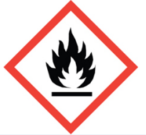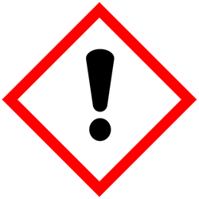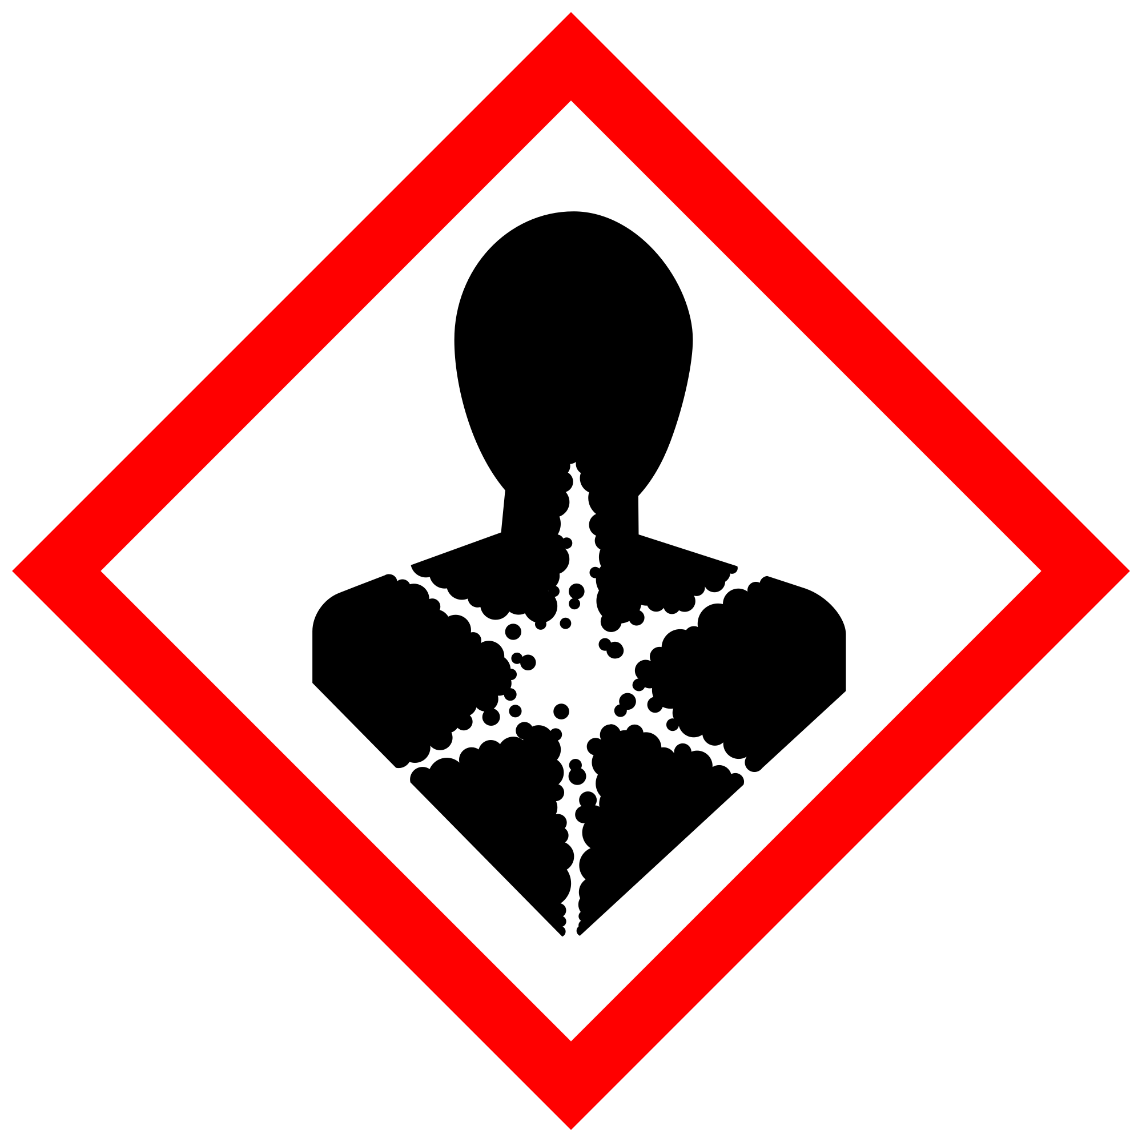

Section 3 – Engineering Controls and Personal Protective Equipment (PPE)

Engineering controls
Use in a fume hood only
Any chemical fume hood used must be tested and passed by EH&S.

Hygiene measures
Avoid contact with skin, eyes, and clothing. Wash hands after removing PPE, before breaks, and immediately after handling the chemical. Gloves should be replaced if in contact with solvents.

Skin and body protection
Chemically compatible laboratory coats that fully extend to the wrist must be worn and be appropriately sized for the individual and buttoned to their full length. Personnel must also wear full-length pants, or equivalent, and close-toe shoes. The area of skin between the shoe and ankle must not be exposed.

Hand protection
Nitrile gloves are required for the activities described in this SOP.
Gloves must be inspected prior to use, including a check for pinholes.
Use proper glove removal technique (without touching glove’s outer surface) to avoid skin contact with this product. Dispose of contaminated gloves after use in accordance with applicable laws and good laboratory practices. Wash and dry hands immediately after glove removal.

Eye protection
ANSI Z87.1-compliant splash goggles are required for all work with organic solvents. Ordinary prescription glasses will NOT provide adequate protection unless they also meet the Z87.1 standard and have compliant side shields.

Respiratory protection
Respiratory protection is not required for the activities described in this SOP.

Section 4 – Special handling and storage requirements
Store away from strong oxidizers such as chromic or nitric acid. Keep in a flammable cabinet when not in use or flammable approved fridge. Dispense in fume hoods.

Section 5 – Spill and accident procedures
Small spills (<100mL) can be wiped with a paper towel and left in the back of the fume hood.
Large spills (100-1000mL) should be cleaned by qualified staff or graduate students only. Evacuate students from the area, use an absorbent pad and place in a fume hood to evaporate
Large spills (1L + ). Evacuate the room and contact a supervisor for assistance
Chemical spills must be cleaned up as soon as possible by properly protected and trained personnel. All other persons should leave the area.
Do not attempt to clean up any spill if not trained or comfortable. Evacuate the area and call 9-1-1 on campus phone for help if there is a significant injury/exposure or if there is no staff support available. If a person is injured, exposed or suspected of being exposed, call 9-1-1 and follow the EXPOSURE PROCEDURES (below).
For questions on spill cleanup, contact EH&S spill consultants at 206‐543‐0467 during normal business hours (Monday-Friday, 8 a.m. to 5 p.m.).
Any spill, exposure or near miss incident requires the involved person or supervisor to complete and submit the UW Online Accident Reporting System (OARS) form on the EH&S website within 24 hours (certain types of incidents require immediate notification).
Exposures: If a person is injured, exposed, or suspected of being exposed to solvents, follow procedures listed here:
- Small exposures will evaporate quickly and do not pose risk to people. Monitor the affected area and refer them to seek medical care if any rash or exposure symptoms occur. Wash affected area under sink if necessary
- Inhalation exposure: Move out of contaminated area; get medical help if person has symptoms.
- Skin exposure: Use the nearest safety shower or sink for 15 minutes; stay under the shower and remove clothing; use a clean lab coat or spare clothing for cover‐up.
- Eye exposure: Use the eye wash for 15 minutes while holding eyelids open.

Get Help.
- Call 9-1-1 or go to nearest Emergency Department (ED); provide details of exposure:
    - Agent
    - Dose
    - Route of exposure
    - Time since exposure
- Bring the SDS and this SOP to the Emergency Department
- Notify your supervisor as soon as possible for assistance
- Secure the area before leaving; lock doors and indicate spill if needed
Report the incident to Environmental Health & Safety.
- Notify EH&S immediately after providing first aid and/or getting help.
  - During business hours (M‐F/8‐5), call 206‐543‐7262.
  - Outside of business hours, call 206‐685‐UWPD (8973) to be routed to EH&S Staff On Call.
- Any spill, exposure or near miss incident requires the involved person or supervisor to complete and submit the UW Online Accident Reporting System (OARS) form on the EH&S website within 24 hours (certain types of incidents require immediate notification).

Section 6 – Waste accumulation and disposal procedures
Waste should be collected in approved containers labeled with a Hazardous Waste Label. Organic solvents should be only wasted in organic waste streams and never mixed with Acids, bases, or oxidizers.

Section 7 – Protocol
Various – See lab manuals
NOTE: Any deviation from this SOP requires approval from Principal Investigator.

Section 8 – Special Precautions for animal use (☐Yes ☒ No)

PARTICULARLY HAZARDOUS SUBSTANCE INVOLVED?
☐YES: Sections #9 to #11 are Mandatory.
☒NO: Sections #9 to #11 are Optional.

