Standard Operating Procedure
Peroxide Formers

Section 1 – Lab-Specific Information
Chemical(s) covered by this SOP: Diethyl Ether, THF, Dioxane, isopropyl ether, others found in https://www.ehs.washington.edu/system/files/resources/Peroxide_Forming_Chemicals.pdf
Building/Room(s) covered by this SOP: Bagley, Chemistry Building
Unit or department: Chemistry
Principal Investigator Name:
Principal Investigator Signature/Date:

Important Definitions
- Autoxidation: the spontaneous oxidation of a compound in air. In the presence of oxygen, ethers slowly autoxidize to form hydroperoxides and dialkyl peroxides. If concentrated or heated, these peroxides may explode.
- Peroxide: any of a class of chemical compounds in which two oxygen atoms are linked together by a single covalent bond

Section 2 – Hazards
Autoxidation in common laboratory solvents can lead to unstable and potentially explosive peroxide formation. The reaction can be initiated by exposure to air, heat, light, or contaminants. Many of these solvents are available with inhibitors to slow the peroxide formation. Examples of inhibitors include BHT (2,6-di-tert-butyl-4-methyl phenol) and Hydroquinone. Peroxides formed in organic compounds can cause serious accidents. In some circumstances, peroxides become low power explosives. In other circumstances, they are sensitive to shock, sparks, and flames. The danger is increased when a peroxide forming chemical is concentrated by distillation or evaporation.
Refer to the EH&S Guidelines for Peroxide Forming Chemicals for detailed information on categories of peroxide former. The retention times and testing requirements for the different categories of peroxide formers are listed in Section 4.

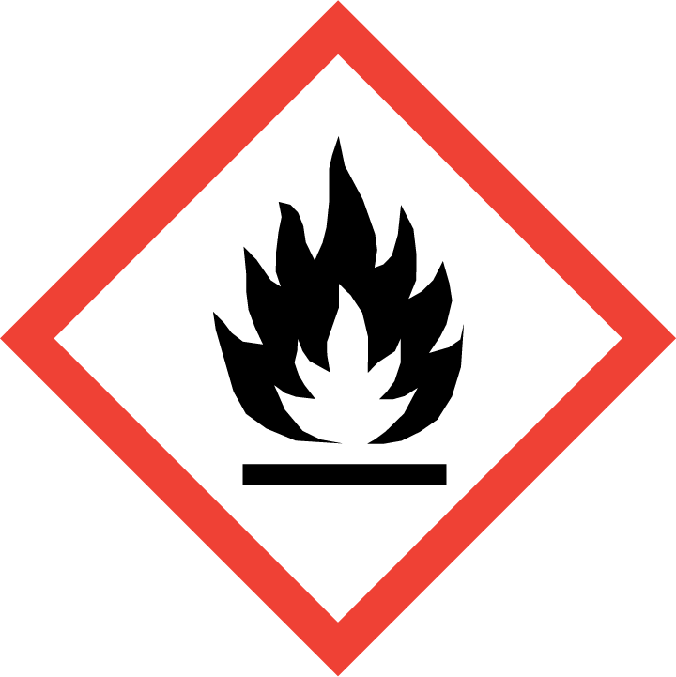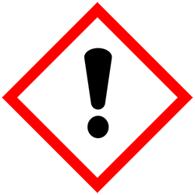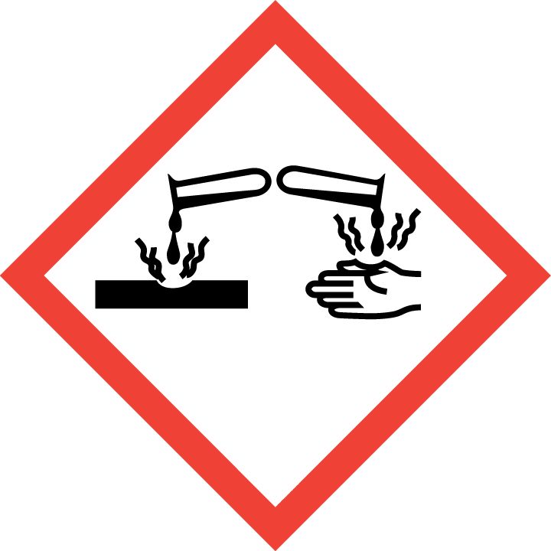
If organic peroxides have formed, an explosive hazard may be present.
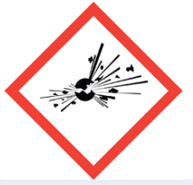
Section 3 – Engineering Controls and Personal Protective Equipment (PPE)
Engineering Controls
Use of peroxide-forming chemicals should be conducted in a properly functioning chemical fume hood or glove box whenever possible.
Bottle should be dated when received and opened. Attach a peroxide test sticker and test every 3 months
Any chemical fume hood used must be tested and passed by EH&S.
Hygiene Measures
Avoid contact with skin, eyes, and clothing. Wash hands after removing PPE, before breaks, and immediately after handling the chemical. If peroxide formers come(s) into contact with any PPE, the PPE shall be immediately removed and discarded properly. Any potentially exposed body parts should be washed immediately.

Skin and body protection
Chemically compatible laboratory coats that fully extend to the wrist must be worn and be appropriately sized for the individual and buttoned to their full length. Personnel must also wear full-length pants, or equivalent, and close-toe shoes. The area of skin between the shoe and ankle must not be exposed.

When handling potentially old peroxide forming compounds, wear Nomex or other fire resistant lab coat

Hand protection
Hand protection is required for the activities described in this SOP. Chemical-resistant gloves must be worn, nitrile gloves are recommended only for low volume applications. For high volume applications, disposable gloves are not appropriate; a heavy-duty glove is required.
Gloves must be inspected prior to use, including a check for pinholes.
Use proper glove removal technique (without touching glove’s outer surface) to avoid skin contact with this product. Dispose of contaminated gloves after use in accordance with applicable laws and good laboratory practices. Wash and dry hands immediately after glove removal.
Eye Protection
ANSI Z87.1-compliant eye protection is required for all work with peroxide formers. Ordinary prescription glasses will NOT provide adequate protection unless they also meet the Z87.1 standard and have compliant side shields.
Respiratory Protection
Respiratory protection is not required for the activities described in this SOP.

Section 4 – Special Handling and Storage Requirements
- Peroxide formation is prevented by strict inventory control of opened peroxidizable chemicals.
- Peroxide-forming chemicals should be regularly tested for organic peroxides.
- Label all containers with “date received” upon arrival to the laboratory.
- Do not over purchase; only purchase what can be safely stored in the laboratory. Peroxide-forming chemicals typically have a short shelf life.
- Label all containers with “date opened” and “expiration date” upon opening of the container.
- If transferred to another container, label with the date the original container was opened.
- Discard any remaining chemical at the end of the time limit/expiration date.
- Do not open containers that show any sign of aging or crystal formation.
- Avoid contact with skin, eyes, and inhalation. Avoid inhalation of vapor or mist.
- Keep away from acids, bases, and oxidizers.
- Store in metal safety cans if possible or store in air-tight, light-resistant containers.
- Keep containers securely closed.
- Store in a cool, dry, and well-ventilated area away from sunlight and incompatible substances such as acids, bases, and oxidizers.
- If possible, store peroxide-forming solvents at low temperatures. These chemicals should never be frozen.
- Opened containers of peroxide formers must be carefully resealed and kept upright to prevent leakage.
- Clean the [specify ventilation control] upon completion of tasks with [specify cleaning solution].
- Clean all contaminated surfaces with [specify cleaning solution] and dry.
- Place all contaminated disposable items in appropriate laboratory waste for disposal.
- Non‐disposable/re‐usable utensils, glassware, and other surfaces contaminated with [chemical(s)] must be decontaminated at the end of the laboratory work session. Complete this inside [specify ventilation control] before removing any of the items.
- When work is completed, remove gloves and wash hands with soap and water.

Section 5 – Spill and Accident Procedures
Chemical spills must be cleaned up as soon as possible by properly protected and trained personnel. All other persons should leave the area.
Collect spilled materials in an appropriate container add a peroxide test sticker (test), then submit to EH&S immediately
Do not attempt to clean up any spill if not trained or comfortable. Evacuate the area and call 9-1-1 on campus phone for help. If the spill is out of control, call 9-1-1. If a person is injured, exposed or suspected of being exposed, call 9-1-1 and follow the EXPOSURE PROCEDURES (below).
For questions on spill cleanup, contact EH&S spill consultants at 206‐543‐0467 during normal business hours (Monday-Friday, 8 a.m. to 5 p.m.).
Any spill, exposure or near miss incident requires the involved person or supervisor to complete and submit the Online Accident Reporting System (OARS) form on the EH&S website within 24 hours (certain types of incidents require immediate notification) at oars.ehs.washington.edu.
Exposures: If a person is injured, exposed, or suspected of being exposed to [chemical(s)], follow procedures listed here:
INSERT IF APPLICABLE - Descriptions of any specialized emergency procedures for locations outside of a UW campus or facility.
Perform first aid immediately.
- Inhalation exposure: Move out of contaminated area; get medical help.
- Sharps injury (needle stick or subcutaneous exposure): Scrub exposed area thoroughly for 15 minutes using warm water and sudsing soap.
- Skin exposure: Use the nearest safety shower or sink for 15 minutes; stay under the shower and remove clothing that was exposed; use a clean lab coat or spare clothing for cover‐up.
- Eye exposure: Use the eye wash for 15 minutes while holding eyelids open.
Get Help.
- Call 9-1-1 or go to nearest Emergency Department (ED); provide details of exposure:
    - Agent
    - Dose
    - Route of exposure
    - Time since exposure
- Bring the SDS and this SOP to the Emergency Department
- Notify your supervisor as soon as possible for assistance
- Secure the area before leaving; lock doors and indicate spill if needed
Report the incident to Environmental Health & Safety.
- Notify EH&S immediately after providing first aid and/or getting help.
  - During business hours (M‐F/8‐5), call 206‐543‐7262.
  - Outside of business hours, call 206‐685‐UWPD (8973) to be routed to EH&S Staff On Call.
- The involved person or supervisor submits the UW Online Accident Reporting System (OARS) form on the EH&S website within 24 hours (certain types of incidents require immediate notification) at oars.ehs.washington.edu.
Section 6 – Waste Disposal Procedures
EH&S will not collect any peroxide forming chemicals that has exceeded its retention time unless the peroxide concentration has been reduced to 10ppm or lower. Refer to EH&S Guidelines on Peroxide Forming Chemicals for detailed instructions on how to test for peroxide-formation and complete the steps outlined for peroxide forming chemicals that have exceeded their retention time before requesting disposal.
Store hazardous waste in closed containers that are properly labeled, and in a designated area away from incompatible chemicals.
Accumulate waste at the point of generation in a sturdy, [compatible container], with a securely-closable/screw‐top lid.
All chemical waste containers must be labeled with a UW Hazardous Waste Label. Refer to How to Label Chemical Waste Containers.
To request a collection of chemical waste, submit a form on the Chemical Waste Disposal webpage on the EH&S website or directly in MyChem inventory. Contact EH&S at 206.616.5835 or chmwaste@uw.edu with questions.
Work area decontamination procedures as appropriate for the chemical in use should be followed.

Section 7 – Protocol (Add lab specific Protocol/Procedure here)
REQUIRED - Insert or attach detailed laboratory-specific procedures for the process, hazardous chemical(s), or hazard class. You may also include any relevant supporting resources such as journal citations, etc. that are applicable
Refer to Section 2 of the UW Laboratory Safety Manual on the EH&S website for additional guidance on chemical management and preparation for use for particularly hazardous substances (PHSs).
NOTE: Any deviation from this SOP requires approval from Principal Investigator.

Section 8 – Special Precautions for animal use ( Yes No)
N/A

PARTICULARLY HAZARDOUS SUBSTANCE INVOLVED?
YES: Sections #9 to #11 are Mandatory.
NO: Sections #9 to #11 are Optional.
EH&S flags Particularly Hazardous Chemicals in MyChem based on hazards.

Section 9 – Approvals required
All staff working with peroxide-formers must be trained on this SOP prior to starting work. They must also review the [chemical] SDS, and it must be readily available in the laboratory. All training must be documented and maintained by the PI or their designee.
Describe any requirements for obtaining authorization before use of the chemical for the procedure, operation, or activity can be performed.
Examples:
- A worker must have [specific training] documented before performing described procedure for the first time.
- A medical examination must be completed prior to respirator use (for lead, dust, pathological organisms).
- Other authorizations required before a person can independently perform a process using a particularly hazardous substance.

Section 10 – Decontamination
Include work area decontamination procedures as appropriate for the chemical in use:

REQUIRED - Insert descriptions of decontamination procedures for equipment, glassware, controlled areas (e.g., glove boxes, restricted access hoods, perchloric/hot acid fume hoods, designated laboratory areas), include cleaning solutions and materials.

Section 11 – Designated area

REQUIRED - Identify specific areas where the particularly hazardous chemicals may be used (e.g., glove boxes, restricted access hoods, perchloric/hot acid fume hoods, or designated portions of the laboratory).

Section 12 – Documentation of training (signature of all users is required)
- Prior to using substances included in this SOP, laboratory personnel must be trained on the hazards described in this SOP, how to protect themselves from the hazards, and emergency procedures.
- Ready access to this SOP and to a Safety Data Sheet for each hazardous material described in the SOP must be made available in the lab space(s) where these substances are used.
- The Principal Investigator (PI), or Responsible Party, if the activity does not involve a PI, must ensure that their laboratory personnel have attended appropriate laboratory safety training (and refresher training where applicable).
- Training must be repeated following any revision to the content of this SOP.
- Training must be documented. This training sheet is provided as one option; other forms of training documentation (including electronic) are acceptable but records must be accessible and immediately available upon request.
I have read and understand the content of this SOP:
Name | Signature | Date

