Standard Operating Procedure
Oxidizers

Section 1 – Lab-Specific Information
Chemical(s) covered by this SOP: Hydrogen Peroxide, Potassium Perchlorate, Potassium Permanganate and Sodium Dichromate
Building/Room(s) covered by this SOP: Bagley, Chemistry Building
Unit or department: Chemistry
Principal Investigator Name:
Principal Investigator Signature/Date:

Important Definitions
- Oxidizing liquid- a liquid which, while by itself, is not necessarily combustible, may generally by yielding oxygen, cause or contribute to the combustion of other material. Hydrogen peroxide, nitric acid, and nitrate solutions are examples of oxidizing liquids commonly found in a laboratory.
- Oxidizing solid- a solid which, while by itself, is not necessarily combustible, may generally by yielding oxygen, cause or contribute to the combustion of other material.

Section 2 – Hazards
Oxidizer should be kept away from heat, clothing, and other combustible materials. Take any precaution to avoid mixing with combustibles and store away from combustibles. Oxidizers can have other associated hazards, such as corrosive or toxic (e.g., nitric acid, sodium nitrite). Make sure that all of the potential hazards are understood before handling any chemical.
Common oxidizers include hydrogen peroxide, nitric acid, nitrate and nitrite compounds, perchloric acid and perchlorate compounds, and Hypochlorite compounds, such as household bleach. Oxidizers have a wide variety of applications including cleaners and disinfectants, agricultural fertilizers, rocket propellant and fuel, and explosives.
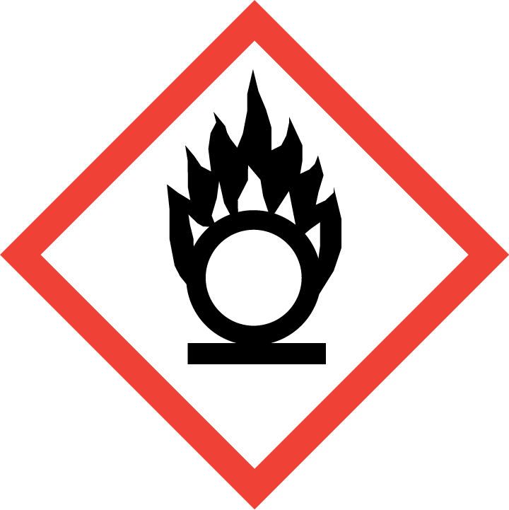
Section 3 – Engineering Controls and Personal Protective Equipment (PPE)
Engineering Controls
Use of oxidizing liquids or oxidizing solids should be conducted in a properly functioning chemical fume hood whenever possible.
Hygiene Measures
Avoid contact with skin, eyes, and clothing. Wash hands after removing PPE, before breaks, and immediately after handling the chemical. If oxidizers come(s) into contact with any PPE, the PPE shall be immediately removed and discarded properly. Any potentially exposed body parts should be washed immediately.

Skin and body protection
Chemically compatible laboratory coats that fully extend to the wrist must be worn and be appropriately sized for the individual and buttoned to their full length. Personnel must also wear full-length pants, or equivalent, and close-toe shoes. The area of skin between the shoe and ankle must not be exposed.

Hand protection
Hand protection is required for the activities described in this SOP. Chemical-resistant gloves must be worn, nitrile gloves are recommended for low volume applications. For high volume applications, disposable gloves are not appropriate; a heavy-duty glove is required.
Gloves must be inspected prior to use, including a check for pinholes.
Use proper glove removal technique (without touching glove’s outer surface) to avoid skin contact with this product. Dispose of contaminated gloves after use in accordance with applicable laws and good laboratory practices. Wash and dry hands immediately after glove removal.
Eye Protection
ANSI Z87.1-compliant eye protection is required for all work with oxidizers. Ordinary prescription glasses will NOT provide adequate protection unless they also meet the Z87.1 standard and have compliant side shields.
Respiratory Protection
Respiratory protection is not required for the activities described in this SOP. Work should be only performed in fume hoods.

Section 4 – Special Handling and Storage Requirements

- Keep Oxidizers in secondary containment, separate from flammables and reductants.
- Do not over purchase; only purchase what can be safely stored in the laboratory.
- Avoid contact with skin, eyes, and inhalation. Avoid inhalation of vapor or mist. Avoid formation of dust.
- Keep away from combustible materials. Keep away from sources of ignition.
- Avoid using ignition sources (flame burners or any open flame source, hot plates, electrical equipment with frayed or cracked wiring, etc.) and/or creating static electricity in areas where oxidizing chemicals are being used or stored.
- Keep containers tightly closed. Store in a cool, dry, and well-ventilated area away from incompatible substances such as flammable and combustible liquids.
- Keep cool and protected from sunlight.
- Opened containers of oxidizing liquids must be carefully resealed and kept upright to prevent leakage.
- Carefully follow manufacturer’s instructions if oxidizing liquid needs to be vented during storage.
- Place all contaminated disposable items in appropriate laboratory waste for disposal.
- Non‐disposable/re‐usable utensils, glassware, and other surfaces contaminated with oxidizers must be decontaminated at the end of the laboratory work session.
- When work is completed, remove gloves and wash hands with soap and water.

Section 5 – Spill and Accident Procedures
Chemical spills must be cleaned up as soon as possible by properly protected and trained personnel. All other persons should leave the area.
Clean up spills using contents of the laboratory spill kit:
If spill is large or you are uncomfortable with cleaning up a spill yourself, contact your supervisor for assistance.
Do not attempt to clean up any spill if not trained or comfortable. Evacuate the area and call 9-1-1 on campus phone for help. If the spill is out of control, call 9-1-1. If a person is injured, exposed or suspected of being exposed, call 9-1-1 and follow the EXPOSURE PROCEDURES (below).
For questions on spill cleanup, contact EH&S spill consultants at 206‐543‐0467 during normal business hours (Monday-Friday, 8 a.m. to 5 p.m.).
Any spill, exposure or near miss incident requires the involved person or supervisor to complete and submit the Online Accident Reporting System (OARS) form on the EH&S website within 24 hours (certain types of incidents require immediate notification) at oars.ehs.washington.edu.
Exposures: If a person is injured, exposed, or suspected of being exposed to oxidizers, follow procedures listed here:
Perform first aid immediately.
Refer to SDS for additional chemical-specific guidance; include pertinent information here.
- Inhalation exposure: Move out of contaminated area; get medical help.
- Sharps injury (needle stick or subcutaneous exposure): Scrub exposed area thoroughly for 15 minutes using warm water and sudsing soap.
- Skin exposure: Use the nearest safety shower or sink for 15 minutes; stay under the shower and remove clothing if exposed; use a clean lab coat or spare clothing for cover‐up.
- Eye exposure: Use the eye wash for 15 minutes while holding eyelids open.
Get Help.
- Call 9-1-1 or go to nearest Emergency Department (ED); provide details of exposure:
    - Agent
    - Dose
    - Route of exposure
    - Time since exposure
- Bring the SDS and this SOP to the Emergency Department
- Notify your supervisor as soon as possible for assistance
- Secure the area before leaving; lock doors and indicate spill if needed
Report the incident to Environmental Health & Safety.
- Notify EH&S immediately after providing first aid and/or getting help.
  - During business hours (M‐F/8‐5), call 206‐543‐7262.
  - Outside of business hours, call 206‐685‐UWPD (8973) to be routed to EH&S Staff On Call.
- The involved person or supervisor submits the UW Online Accident Reporting System (OARS) form on the EH&S website within 24 hours (certain types of incidents require immediate notification) at oars.ehs.washington.edu.
Refer to SDS for additional chemical-specific guidance; include pertinent information here.
Section 6 – Waste Disposal Procedures
Never mix oxidizers with organic waste, danger of explosion. Keep oxidizer waste separate, label with appropriate hazardous waste sticker and submit to EH&S
All chemical waste containers must be labeled with a UW Hazardous Waste Label. Refer to How to Label Chemical Waste Containers.
To request a collection of chemical waste, submit a form on the Chemical Waste Disposal webpage on the EH&S website or directly in MyChem inventory. Contact EH&S at 206.616.5835 or chmwaste@uw.edu with questions.
Work area decontamination procedures as appropriate for the chemical in use should be followed.

Section 7 – Protocol (Add lab specific Protocol/Procedure here)
REQUIRED - Insert or attach detailed laboratory-specific procedures for the process, hazardous chemical(s), or hazard class. You may also include any relevant supporting resources such as journal citations, etc. that are applicable
NOTE: Any deviation from this SOP requires approval from Principal Investigator.

Section 8 – Special Precautions for animal use ( Yes No)
N/A
PARTICULARLY HAZARDOUS SUBSTANCE INVOLVED?
YES: Sections #9 to #11 are Mandatory.
NO: Sections #9 to #11 are Optional.
EH&S flags Particularly Hazardous Chemicals in MyChem based on hazards.

Section 9 – Approvals required
All staff working with [chemical] must be trained on this SOP prior to starting work. They must also review the [chemical] SDS, and it must be readily available in the laboratory. All training must be documented and maintained by the PI or their designee.
Describe any requirements for obtaining authorization before use of the chemical for the procedure, operation, or activity can be performed.
Examples:
- A worker must have [specific training] documented before performing described procedure for the first time.
- A medical examination must be completed prior to respirator use (for lead, dust, pathological organisms).
- Other authorizations required before a person can independently perform a process using a particularly hazardous substance.

Section 10 – Decontamination
Include work area decontamination procedures as appropriate for the chemical in use:

REQUIRED - Insert descriptions of decontamination procedures for equipment, glassware, controlled areas (e.g., glove boxes, restricted access hoods, perchloric/hot acid fume hoods, designated laboratory areas), include cleaning solutions and materials.

Section 11 – Designated area

REQUIRED - Identify specific areas where the particularly hazardous chemicals may be used (e.g., glove boxes, restricted access hoods, perchloric/hot acid fume hoods, or designated portions of the laboratory).

Section 12 – Documentation of training (signature of all users is required)
- Prior to using substances included in this SOP, laboratory personnel must be trained on the hazards described in this SOP, how to protect themselves from the hazards, and emergency procedures.
- Ready access to this SOP and to a Safety Data Sheet for each hazardous material described in the SOP must be made available in the lab space(s) where these substances are used.
- The Principal Investigator (PI), or Responsible Party, if the activity does not involve a PI, must ensure that their laboratory personnel have attended appropriate laboratory safety training (and refresher training where applicable).
- Training must be repeated following any revision to the content of this SOP.
- Training must be documented. This training sheet is provided as one option; other forms of training documentation (including electronic) are acceptable but records must be accessible and immediately available upon request.
I have read and understand the content of this SOP:
Name | Signature | Date

